Slug Diplomacy

System Test Procedure

Version 2.0

14 March 2002

Team Member | Email | Role
Eric Sunalp  Ian Turner  Andrew Woodruff  Mathew Malone | vector@pipeline.com  woodruff@cats.ucsc.edu  malone@cats.ucsc.edu | Formatter and Traceability Matrix  Test Cases  Test Cases and Traceability Matrix  Test Cases and Screenshots

Configuration Change Record (CCR)

Date | Version | Changes/Additions | Responsible Person
03/12/2002  03/14/2002 | 1.0  2.0 | Initial release of Sytem Test Procedure  Updated the Requirement parameters and traceability matrix | Eric, Ian, Andrew, Mat  Eric, Ian, Andrew, Mat

1 Test Procedure 3
1.1 Starting a New Game 3
1.2 How to chat with other players 4
1.2.1 Selecting a player for chat directly 5
1.2.2 Selecting all players for chat 5
1.2.3 Sending chat messages 5
1.3 Game Play 6
1.3.1.1 Moving an Army 6
1.3.1.2 To Support an Army 7
1.3.1.3 To order an Army to Hold 8
1.3.2 Order Resolution/ Retreating Round 9
1.3.2.1 To order an Army to Retreat 9
1.3.3 Army Adjustment Round 10
1.3.3.1 To construct new armies 10
1.3.3.2 To disband armies 11
1.3.3.3 Forced Disbandment 12
1.3.4 Ending a turn 13
1.3.5 Quitting the game 13
1.3.6 Illegal actions 13
1.3.7 More complex move combinations 14
1.3.7.1 Cutting support 14
1.3.7.2 Cutting the cutting of support 14
1.3.7.3 Rotation of armies 14
1.3.8 Network and/or Server Failure 15
2 Tracability Matrix 15

Test Procedure

Starting a New Game

The game starts as soon as a the server connection is established. See figure 3 for an example of what the screen will look like when you first make a connection.
Precondition: Game has been installed on the server.

User Action | Expected Results | Pass/Fail | Comments | Req Para.
- Server administrator starts server for 1 player. (ie java Server 1) | - Server starts listening for client connections |  |  | 6.1
- One Player: Browse to the web location given by the server administrator. The game will open in the browser window. | - Game initializes and displays following active components.  - A main window will display map of middle earth.  - A list of teams playing the game, consisting only of this user (since she’s the only one playing).  - A dropdown menu list of armies.  - A button allows you to enter your orders.  - A button that allows you to end your turn.  - A chat box.  - A button to send your text to the chat box.  - An order history area. |  |  | 6.1  7.1.1  7.1.2  7.1.3
- Restart server for Two Players. | - Server starts listening for client connections |  |  | 6.1
- Two Players: Browse to the web location given by the server administrator. The game will open in the browser window. | - Same as above except a list of teams playing the game, consisting of two teams. |  |  | 6.1  7.1.1  7.1.2  7.1.3
- Restart server for Three Players. | - Server starts listening for client connections |  |  | 6.1
- Three Players: Browse to the web location given by the server administrator. The game will open in the browser window. | - Same as above except a list of teams playing the game, consisting of three teams. |  |  | 6.1  7.1.1  7.1.2  7.1.3
- Restart server for Four Players. | - Server starts listening for client connections |  |  | 6.1
- Four Players: Browse to the web location given by the server administrator. The game will open in the browser window. | - Same as above except a list of teams playing the game, consisting of four teams. |  |  | 6.1  7.1.1  7.1.2  7.1.3
- Restart server for Five Players. | - Server starts listening for client connections |  |  | 6.1
- Five Players: Browse to the web location given by the server administrator. The game will open in the browser window. | - Same as above except a list of teams playing the game, consisting of five teams. |  |  | 6.1  7.1.1  7.1.2  7.1.3

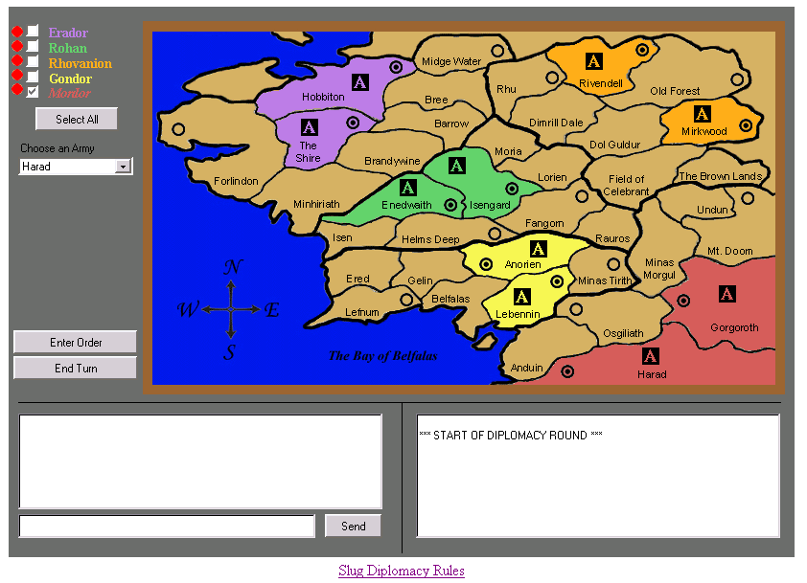

Figure 3. Starting Slug Diplomacy

How to chat with other players

Players may send messages to any other players in the game.
Equivalence classes: This verifies that chat works for all players.
- Test with second player.
Precondition: Players have joined game and not currently in retreat round, game has at least two players.

Selecting a player for chat directly
User Action | Expected Results | Pass/Fail | Comments | Req Para.
1. As the first player, click the box next to the second player’s name. | - Recipient is shown as deselected. |  |  | 6.2  7.4.1
2. Enter a message in the chat box. | - Message appears in chat box |  |  | 6.2
3. Click “Send” | - Message is not sent to the second player.  - Message appears in the first player’s chat history. |  |  | 6.2  7.4.1
4. Click the box next to the second player’s name | - Recipient is shown as selected. |  |  | 6.2  7.4.1
5. Enter a message in the chat box. | - Message appears in chat box. |  |  | 6.2
6. Click “Send” | - Message appears in the first and second players’ chat histories. |  |  | 6.2  7.4.1

Selecting all players for chat
User Action | Expected Results | Pass/Fail | Comments | Req Para.
1. As the first player, click the box next to the second player’s name | - Recipient is shown as deselected. |  |  | 6.2  7.4.1
2. Click “Select All” | - The second player becomes selected again. |  |  | 6.2  7.5.4
3. Enter a message in the chat box. | - Message appears in chat box. |  |  | 6.2  7.5.4
4. Click “Send” | - Message appears in all players’ chat histories. |  |  | 6.2  7.4.1

Sending chat messages
User Action | Expected Results | Pass/Fail | Comments | Req Para.
1. Enter chat message into text box and click “Send”. | - Message appears in all selected players’ chat boxes. |  |  | 6.2  7.5.4
2. Enter chat message into text box and press the enter key. | - Message appears in all selected players’ chat boxes. |  |  | 6.2  7.5.4

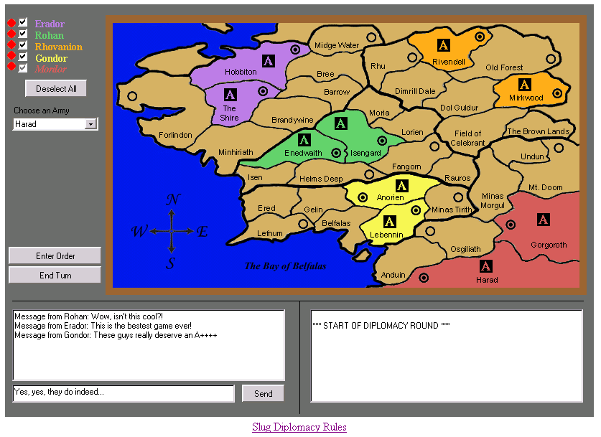
Figure 4. Chat

Game Play
Equivalence classes: This sequence runs a 5-player game, to test game data resolution.
- Tests a 5-player game

Moving an Army
Precondition: Game has started and all players are connected.
Equivalence classes: This sequence tests any move order entered by any player.
- Tests player 5 moving Harad to Anduin.
User Action | Expected Results | Pass/Fail | Comments | Req Para
1. Player selects “Harad” from Army menu  2. Player selects “Move” from order selection menu.  3. Player selects “Anduin”  4. Player clicks on “Done” button. | - Order appers in order history. |  |  | 7.4.2  7.4.3  7.4.4  7.4.5  7.4.6  7.5.2
All players click “End Turn” | - Army at Harad moves to Anduin on the map  - Order appears in revised order history box. |  |  | 7.1.2

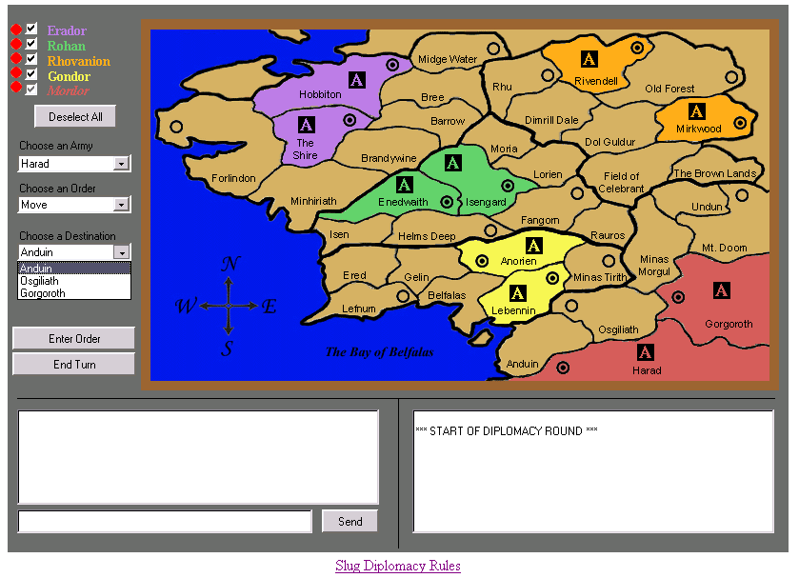
Figure 5. Moving an Army

To Support an Army
Precondition: Game has started and all players have connected.
See figure 6 for the output after the player selects the action.
Equivalence classes: This sequence tests any support order entered by any player.
- Tests player 5 ordering Harad to support Lebennin moving to Osgilath.
User Action | Expected Results | Pass/Fail | Comments | Req Para
1. Player selects “Harad” from Army menu.  2. Player selects “Support” from order selection menu.  3. Player selects “Lebennin” from menu entitled “Which Army to Support”.  4. Player selects “Osgilath” from the menu entitled “Army’s Destination”.  5. Player clicks on “Done” button. | - Order appears in order history |  |  | 7.4.2  7.4.3  7.4.4  7.4.5  7.4.6  7.5.2
All players click “End Turn” | - No armies move (Lebennin was not given an order)  - Order appears in revised order history box. |  |  | 7.1.2
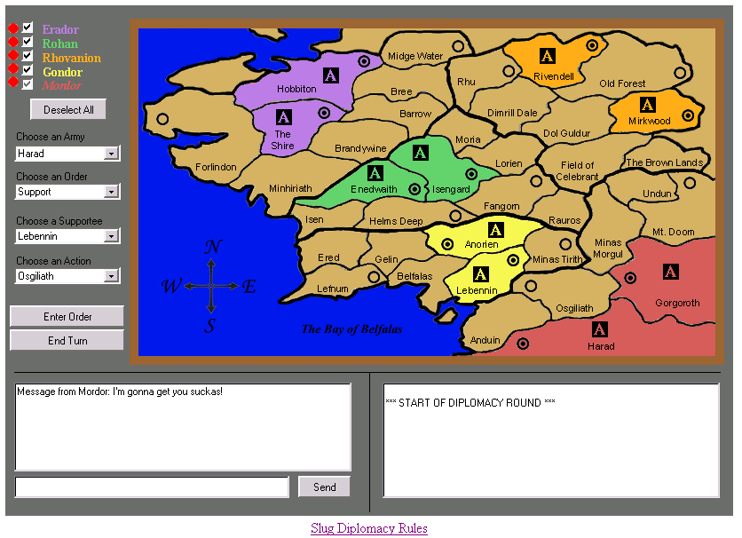
Figure 6. Supporting an Army

To order an Army to Hold
Precondition: Game has started and all players have connected.

Equivalence classes: This sequence tests any hold order entered by any player.
- Tests player 5 ordering Harad to hold.

See figure 6 for an example of the screen after actions in the following table.

User Action | Expected Results | Pass/Fail | Support | Req Para
1. Player selects “Harad” from army selection menu.  2. Player selects “Hold” from order selection menu.  3. Player clicks on “Done” button. | a) Order appears in order history |  |  | 7.4.2  7.4.3  7.4.4  7.4.5  7.4.6  7.5.2
All players click “End Turn” | - No armies move.  - Order appears in revised order history box. |  |  | 7.1.2

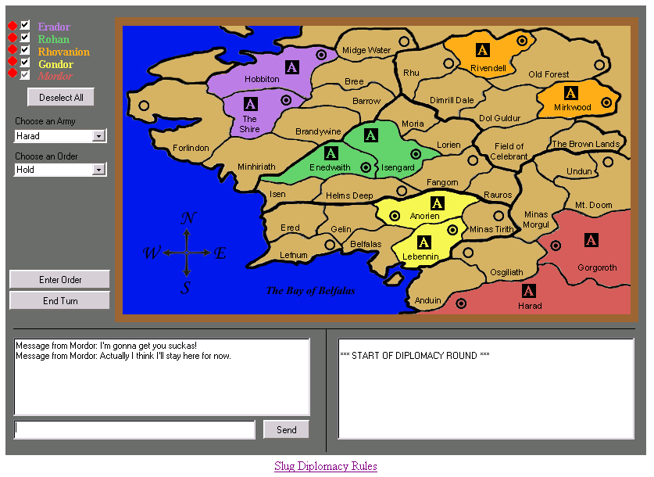
Figure 6. Holding an Army

Order Resolution/ Retreating Round

In the Order Resolution/Retreating Round, players may select retreating orders for their losing armies, if any. See figure 7 for an example of the order resolution phase.

To order an Army to Retreat
Precondition: Game has started and all players have connected.
Equivalence classes: This sequence tests any retreat order entered by any player.
Tests player 5 ordering Osgilath to retreat to Anduin.
User Action | Expected Results | Pass/Fail | Comments | Req Para
Players enter orders as follows:  - Harad moves to Osgilath  - Anorien moves to Minas Tirith | a) Each player’s orders appear in the order history box. |  |  | 7.1.2 (d)  7.1.2 (j)  7.4.2
All players select “End Turn” | a) Game board updates to new position (both moves successful) |  |  | 7.1.2
Players enter orders as follows:  - Lebennin moves to Osgilath  - Minas Tirith supports Lebennin moving to Osgilath | a) Each player’s orders appear in the order history box. |  |  | 7.1.2 (d)  7.1.2 (j)  7.4.2
All players select “End Turn” | - Game board updates to new position (Lebennin moves to Osgilath)  - Player 5 presented with a retreating round. |  |  | 7.1.2
1. Player 5 selects Osgilath from army selection menu.  3. Player selects “Anduin” from the menu entitled “Retread to Where?”.  4. Player clicks on Done button. | a) Order appears in the order history box |  |  | 7.4.3  7.4.4  7.4.5  7.4.6  7.5.2
All players select “End Turn” | - Retreat shown as successful  - All players see retreat order in order history box. |  |  | 7.1.2

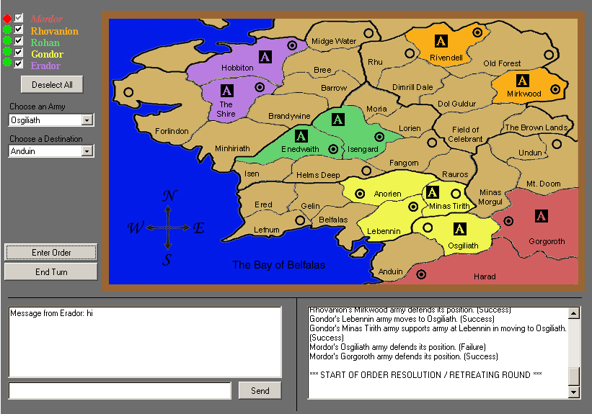
Figure 7. Retreating

Army Adjustment Round

The Army Adjustment Round occurs every other turn, and allows players to add or subtract armies based on their number of controlled supply depots. See figure 8 for an example of the army adjustment phase.

To construct new armies
Precondition: Test 1.3.2.1 executed.
Equivalence classes: This sequence tests any add army order entered by any player.
Tests player 4 adding army at Lebennin.

User Action | Expected Results | Pass/Fail | Comments | Req Para
Player 4 clicks on “Lebennin”  Player clicks on Adjust Armies button. | Orders appear in order history box. |  |  | 7.4.3  7.4.4  7.4.5  7.4.6  7.5.2
All players click Adjust Armies | New army appears at Lebennin. |  |  | 7.1.2

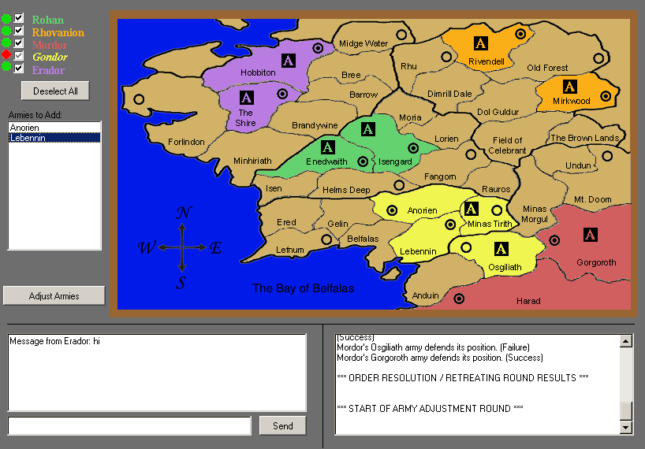
Figure 8. Adding Armies

To disband armies
Precondition: Test 1.3.3.2 executed.
Equivalence classes: This sequence tests any remove army order entered by any player.
1) Tests player 4 adding army at Lebennin.

See figure 9 for an example of an order to disband.

User Action | Expected Results | Pass/Fail | Comments | Req Para
Game proceeds as follows:  First Round  - Osgilath moves to Harad  Second Round  - No orders this round | Game proceeds according to rules. |  |  | 7.3  7.1.2 (d)  7.1.2 (j)  7.4.2
Player clicks on “Anduin”  Player clicks on Adjust Armies button. | Orders appear in order history box. |  |  | 7.4.3  7.4.4  7.4.5  7.4.6  7.5.2
All players click Adjust Armies | New army appears at Lebennin. |  |  | 7.1.2
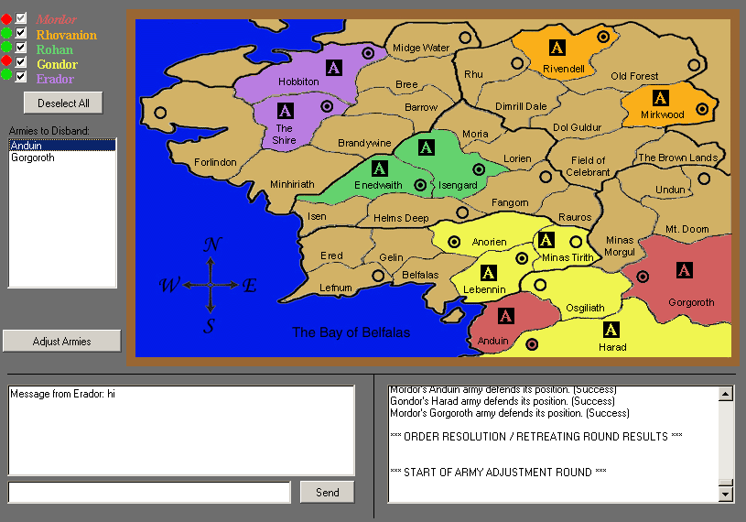
Figure 9. Disbanding Armies

Forced Disbandment
Precondition: Test 1.3.3.3 executed.
Equivalence classes: This sequence tests the provision of a remove order by the game, if a player fails to specify one.
- Tests player 3 losing army at Gorgoroth.

User Action | Expected Results | Pass/Fail | Comments | Req Para
Game proceeds as follows:  First Round  - Gorgoroth moves to Minas Morgul  Second Round  - Harad moves to Gorgoroth | Game proceeds according to rules. |  |  | 7.3  7.1.2 (d)  7.1.2 (j)  7.4.2
All players click Adjust Armies | Army at Minas Morgul lost |  |  | 7.1.2

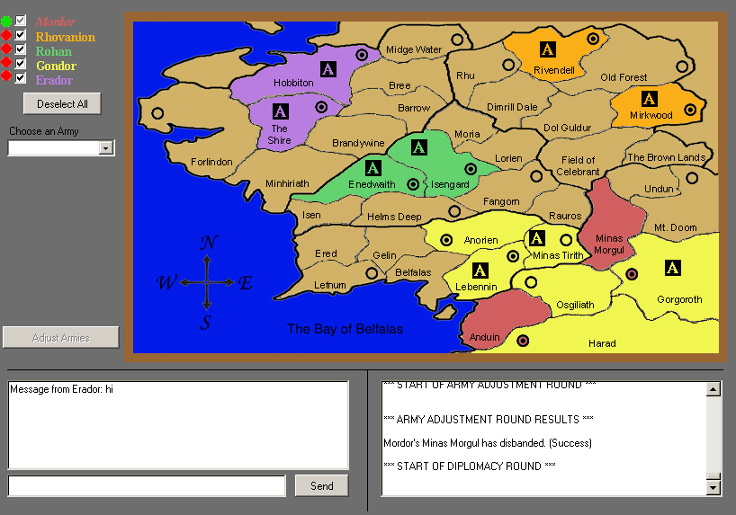
Figure 10. Forced Disbandment

Ending a turn

User Action | Expected Results | Pass/Fail | Comments | Req Para
1. Player clicks on the “End Turn” button. | The current player’s checkbox becomes checked. This change is reflected for all players.  When all players have selected “End Turn”, orders are executed, the map updates, and the game proceeds to the next round. |  |  | 7.4.5  7.4.6  7.5.1

Quitting the game

User Action | Expected Results | Pass/Fail | Comments | Req Para
1. Player closes the web browser or browses to a different page. | a) Game disconnects from the server and exits. |  |  | 7.2  7.2.1

Illegal actions

User Action | Expected Results | Pass/Fail | Comments | Req Para
1. Player clicks on inactive parts of the game screen, such as the map. | a) No response. |  |  | 6.9

More complex move combinations
Equivalence classes: These tests exercise more complicated interactions of moves.
- Cutting support
- Cutting the cutting of support.

Cutting support
Precondition: 5-player game started; all players joined.
User Action | Expected Results | Pass/Fail | Comments | Req Para
Game proceeds as follows:  Round 1:  - The Shire moves to Brandywine  - Hobbiton moves to Barrow  Round 2:  - Barrow moves to Isengard  - Brandywine supports Barrow’s move to Isengard  - Enedwaith moves to Brandywine  - Isengard supports Enedwaith’s support of brandywine | After round 2, the board is in the same position as after round 1. |  |  | 7.3  7.1.2 (d)  7.1.2 (j)  7.4.2

Cutting the cutting of support
Precondition: Execution of test case 1.3.7.1.
User Action | Expected Results | Pass/Fail | Comments | Req Para
Game proceeds as follows:  Round 1:  - Gelin moves to Helms Deep  - Round 2:  - Barrow moves to Isengard  - Brandywine supports Barrow’s move to Isengard  - Enedwaith moves to Brandywine  - Helms Deep moves to Enedwaith | a) After round 2, Barrow successfully moves to Isengard. Player 2 is presented with a retreating option. |  |  | 7.3  7.1.2 (d)  7.1.2 (j)  7.4.2

Rotation of armies
Precondition: Execution of test case 1.3.7.1.
Player Action | Slug Diplomacy | Pass/Fail | Comments | Req Para
Game proceeds as follows:  - Barrow moves to Isengard  - Isengard moves to Enedwaith  - Enedwaith moves to Brandywine  - Brandywine moves to Barrow | a) All orders are successful. |  |  | 7.3  7.1.2 (d)  7.1.2 (j)  7.4.2

Network and/or Server Failure

Player Action | Slug Diplomacy | Pass/Fail | Comments | Req Para
1. Player connects to server | a) Connection should stay stable keeping player connected to server. |  |  | 7.6.1

Tracability Matrix

SRD | Test Procedure Step(s) | Description
6.1 | 1.1 | Game Startup
6.2 | 1.2.1, 1.2.2, 1.2.3 | Chat
6.9 | 1.3.6 | Abnormal Use
7.1.1 | 1.1 | Initialization
7.1.2 | 1.1 | Display Components
7.1.2 (a) | 1.1 (a) | Game Map
7.1.2 (b) | 1.1 (b) | List of Teams
7.1.2 (c) | 1.1 (c) | List of Armies
7.1.2 (d) | 1.1 (c) | List of Orders
7.1.2 (e) | 1.1 (d) | List of Destinations
7.1.2 (f) | 1.1 (e) | Order Submission Button
7.1.2 (g) | 1.1 (f) | End Turn button
7.1.2 (h) | 1.1 (g) | Chat Box
7.1.2 (i) | 1.1 (h) | Chat Submission Button
7.1.2 (j) | 1.1 (i) | Order History
7.1.3 | 1.1 | Control Initialization
7.1.3 (a) | 1.1 (j), 1.1 (k) | Chat boxes initially selected
7.1.3 (b) | 1.1 (k) | Army list active
7.1.3 (c) | 1.1 (k) | Order list active
7.1.3 (d) | 1.1 (k) | Chat box active
7.1.4 (e) | 1.1 (k) | Move history active
7.1.4 (f) | 1.1 (l) | Supply depots assigned and appear on map
7.1.4 (g) | 1.1 (m) | Armies assigned
7.2 | 1.3.5 | deactivation
7.2.1 | 1.3.5 | Method of deactivation
7.3 | 1.3.3.2, 1.3.3.3, 1.3.7.1, 1.3.7.2, 1.3.7.3 | Rules of the game
7.4 | 1 | Playing the game
7.4.1 | 1 | Selecting a particular player for chat
7.4.2 | 1.2.1.1, 1.2.1.2, 1.2.1.3, 1.3.7, 1.3.7.1, 1.3.7.2, 1.3.7.3 | Ordering an army
7.4.3 | 1.2.1.1, 1.2.1.2, 1.2.1.3, 1.3.7, 1.3.7.1, 1.3.7.2, 1.3.7.3 | Finishing an order
7.4.4 | 1.3 | Updating history window
7.4.5 | 1.1 | Updating map window
7.4.6 | 1.1, 1.3 (all subsections) | Updating map window colors
7.5 | 1.1, 1.3 (all subsections) | Control and Status
7.5.1 | 1.1, 1.3 (all subsections) | End of turn after all players accept.
7.5.2 | 1.1, 1.3 (all subsections) | Order controls
7.5.3 | 1.1, 1.3 (all subsections) | Status Window
7.5.4 | 1.1, 1.3 (all subsections) | Chat box and control
7.6.1 | 1.3.8 | Network and/or server failure

