Slug Diplomacy

System Requirements Document (SRD)

Version 2.0

14 March 2002

Team Member | Email | Role
Eric Sunalp  Ian Turner  Andrew Woodruff  Matthew Malone | vector@pipeline.com  woodruff@cats.ucsc.edu  malone@cats.ucsc.edu | Sections 7 – 17  Sections 6, 7 & 16  Section 1 – 5 & 16  Final Reviewer

Configuration Change Record (CCR)

Date | Version | Changes/Additions | Responsible Person
01/22/2002  03/14/2002 | 1.0  2.0 | Initial release of SRD  New screen shots and consistancy across documents | Eric, Ian and Andrew  Eric, Ian, Andrew and Mat

1 PRODUCT OVERVIEW 4
1.1 Description of the Product 4
1.2 Purpose of the Product 4
1.3 Problem Solved by the Product 4
1.4 Objectives of the Product 4
1.5 Special Considerations 4
1.6 Benefit to Business 5
1.7 Schedule and Financial Considerations 5
1.8 Expectations and Limitations of this Product 5
1.9 Summary Description 5
1.10 Acceptance Criteria 5
2 APPLICABLE DOCUMENTS 6
2.1 Reference Documentation 6
2.1.1 Web Sites 6
2.1.2 Books 6
2.2 Slug Diplomacy Project Documentation 6
2.2.1 User Manual (UM) - TBS 6
2.2.2 System Design Document (SDD) - TBS 6
2.2.3 System Test Procedure (STP) - TBS 6
2.2.4 System Test Report (STR) - TBS 6
2.2.5 Slug Diplomacy Coding Standard - TBS 6
3 CONTEXT DIAGRAM 7
4 PRODUCT DETAILS 8
4.1 Who they are 8
4.2 Inclusion Strategy 8
5 CONTRAINTS 8
6 USE CASES 9
6.1 Game startup 9
6.2 Chat 9
6.3 Order history 10
6.4 Diplomacy Round 10
6.4.1 Entering orders 10
6.5 Order Resolution / Retreating Round 11
6.5.1 Entering Retreat Orders 11
6.6 Army Adjustment Round 12
6.6.1 Keeping the same number of armies 12
6.6.2 Adding Armies 12
6.6.3 Subtracting Armies 13
6.7 Winning/Losing the game 13
6.8 Quitting the game 13
6.9 Abnormal Use 14
6.10 Extreme Use 14
7 FUNCTIONS / BEHAVIORS 14
7.1 Activation 14
7.2 Deactivation 15
7.3 Rules of the Game 15
7.4 Game Playing 16
7.5 Control and Status Keeping 17
7.6 Error Conditions 17
7.7 Distinguishing Characteristics 17
8 Attributes 17
8.1 Defining 17
8.2 Distinguishing 18
9 RESPONSIBILITIES 18
10 UNRESOLVED ISSUES 18
11 ASSUMPTIONS 18
11.1 Hunches 18
11.2 Self-Evident 18
11.3 Supporting Evidence 18
11.4 Impositions 18
12 DATA ELEMENTS 19
13 DESIGN DECISIONS 19
13.1 Preemptive Choices 19
13.2 Design Choices 19
14 RISK 19
14.1 Technical Risk 19
14.2 Financial Risk 20
14.3 Schedule Risk 20
14.4 Risk Mitigation Plan 20
15 DOCUMENT CONVENTIONS 20
16 SAMPLE DISPLAYS 21
17 GLOSSARY AND ACRONYM LIST 24

PRODUCT OVERVIEW

Description of the Product

Slug Diplomacy is a simplified version of the turn-based board game Diplomacy, which we are proposing to migrate to computer form. Slug Diplomacy will use a map of the fantasy world Middle Earth, and will be a game of global conquest. Players will compete with each other to take over a majority of the map's supply centers by strategically using their armies and by making alliances with other players. This unique computer version of the Diplomacy will support one to five human players.

Purpose of the Product

To make a computer implementation of the board game Diplomacy that uses simplified rules and is playable over a network. The game's Middle Earth theme will provide an interesting spin to the game.

Problem Solved by the Product

Slug Diplomacy will allow fans of the original game Diplomacy will be able to play other people from the comfort of their own computer, instead of having to gather together a group of players in one location. Its simplified rule system will allow new user s to quickly be able to pick up an understanding of the game that was not possible with the original board game. The Internet lends itself well to the diplomatic aspects of the game (secret agreements between players through chat). The fact that the game will be in software form will speed of certain aspects of it (such as the time it takes to issue moves) and provides the opportunity of later adding computer players.

Objectives of the Product

To develop an online game based on Diplomacy, that will be fairly easy to use, yet still contain the strategic element found in the original version.

Special Considerations

This project will be our first game developed in Java. We have the time constraint that is the length of this class. Not using java swing; instead, we have elected to use java awt for compatibility across platforms.

Benefit to Business

Completion of this project will be a useful accomplishment worth mentioning in job interviews many of our group members will soon be participating in.

Schedule and Financial Considerations

To develop the game in 8 weeks with a team of 4 members who each have other responsibilities, unrelated to the game, to manage.

Expectations and Limitations of this Product

Slug Diplomacy will run on Windows, Macintosh, Sun and Unix based platforms running Internet Explorer 4 and above and Netscape 4 and above. The game will support network play, but is not expected to support saved game status at this time.

Summary Description

The client side of this application is a Java 1.1 applet while the server remains as a stand alone program. Its primary target platform will be PCs running current versions of Windows or Macintosh computers. The game will take care of the duties normally taken on by the "game master" in the original board game of Diplomacy. The user interface will consist of a map of the game and clickable drop-down menus to make orders, and will include a chat window to allow communication between players. On the game map, the owner of a territory will be represented by different colors. Minimal help will be provided to users in the form of a user manual and by disallowing illegal moves to be submitted.

Acceptance Criteria

The product will be accepted based on (1) submission of a System Test Report, with results acceptable to Dr. Kaplan or his representative and (2) three successful plays of the game, as described in the User Manual. Dr. Kaplan or his representative must be one of the players of the game. "Successful" will be defined as operating as described in the User Manual and meeting the performance requirements described in this document. The latest released version of the User Manual will be used. The tests will be run on a Windows platform in JBE 109.

APPLICABLE DOCUMENTS

2.1 Reference Documentation

Web Sites

http://www.sun.com/java - Sun's Java website
http://www.diplomacy-archive.com - Official Diplomacy rules
http://www.jrrtolkien.org.uk/lotrmaps.htm - Used as basis for our game map
http://www.cse.ucsc.edu/classes/cmps115 - Class website

Books

Java In a Nutshell, O'Reilly - Java reference
Software Engineering: A Practitioner's Approach, Roger S. Pressman - class book
Lord of the Rings, Tolkien - used for our Middle Earth theme

Slug Diplomacy Project Documentation

User Manual (UM) – Supplied

Detailed Design Document 1 (DDD1) - Supplied

Detailed Design Document 2 (DDD2) - Supplied

    - Code and Coding Standard (CCS) – Supplied

System Test Procedure (STP) - Supplied

System Test Report (STR) - Supplied

CONTEXT DIAGRAM
Figure 1. Context Diagram for Slug Diplomacy design

PRODUCT DETAILS

Who they are

Name: | Brief Description: | Status: Favored, Disfavored, or Ignored
Game Player | Computer user with Web access | Favored. Only requires approved Internet browser.
Stand alone computer owner | Owns computer but is not connected to the web | Ignored – Could play game over their own LAN.
Non-computer literate person | Cannot use computer or interface with the game. | Ignored – They can play the board game.
Foreign Players | People who do not know English. | Ignored – No other languages will be supported. English version only.
Mouse Problems | People who can’t use mouse. | Disfavored. Can play, but not recommended. Player can use the game by using keyboard accessibility built into their own OS.
Hackers | Will attempt to hack the game. | Disfavored. These people could cheat at the game.

Inclusion Strategy

Limited - Will call on real users from our favored group to come play our final product. While we may gain information by watching them on unclear aspects of the game and also receive feedback from them, we will not ask them to do any QA testing for us.

CONTRAINTS

C1. Slug Diplomacy will support 1 to 5 players per game.
C2. No more than (2³¹)-1 turns will be allowed to take place per game, beyond that point the game behavior is undefined.
C3. Will take no more than 5 seconds for graphics to load when game is first initialized.

USE CASES

Game startup

Precondition
The program has been properly installed and executed by the user.

Postcondition
The game is connected to the network and the user may begin his or her first turn.

Description
How the user runs the program is out of the scope of this document, as we are attempting to run in as many environments as possible. However, once the program is run, the game connects to the network server. The player is assigned a role in the game and may proceed to the Diplomacy stage of the game.

Chat

Precondition
The program is currently running.

Postcondition
A log of all chat dialogue appears in the chat history box (see screenshot).

All requested users receive the message.

Description
The user selects the recipients of his or her message (or may select all recipients by clicking the ``select all'' button) using the selection dialog at the upper-lefthand corner of the window. The user additionally enters his or her message into the message entry box in the lower-lefthand corner. Once both these actions are completed (in either order), the user clicks ``Send'' to send the message.

At this time (or shortly thereafter), the entered message appears in the chat history box of all selected players (and the current player, regardless of whether or not he or she selected his- or herself).

Note that at some stages of the game, the ``Send'' button is disabled, indicating that the user may not send messages.

Order history

Precondition
The program is currently running.

Postcondition
The program is currently running.

Description
At all times during the game, the game log box (in the lower-righthand corner) contains a log of all actions taken by all players thus far in the game, up to (but not including) the current round. Additionally, the log contains orders entered by the user (but not other players) during the current round.

Diplomacy Round

Precondition
The game has just begun; or the Order Resolution round just completed and there was no Army Adjustment round that turn; or the Army Adjustment round has just completed.

Postcondition
The game proceeds to the Order Resolution round

Description
The diplomacy round is the main round of the game, when players actually perform diplomacy and enter their orders.

Entering orders

Precondition
The game is in the Diplomacy round, and the player has not selected ``Done''.

Postcondition
The entered order appears in the log box, and the player may enter another order.

Description
To enter an order, the player first selects the unit to receive the order from a list of all of the player's units, using the first drop-down box on the left.

Then, the player selects the type of order -- hold, move, or support -- using the second drop-down box. Note that support may not be listed if there is no possible supporting move.

If the player selects hold, then the order is complete.

If the player selects move, then the player selects from a list of possible destinations using the third drop-down box.

If the player selects support, then the player selects from a list of possible armies to support. Additionally, the player selects from a list of possible destinations to support, plus ``Defend''. If the player selects ``Defend'', he or she instructs his or her army to defend the selected supported unit. ``Defend'' may not be listed if it is not possible for the selected units to support one another in defense.

In any of the above cases, when the order is entered the user activates the ``Enter Order'' button, which causes the order to appear in the log box, and the order selection drop-down boxes are reset.

Order Resolution / Retreating Round

Precondition
In the Diplomacy round, all players select ``Enter Order''.

Postcondition
If there is an Army Adjustment round this turn, the game proceeds to the Army Adjustment round. Otherwise, the game proceeds to the Diplomacy round.

Description
In the Order Resolution round, all orders from all players are displayed in the log box in the lower-righthand corner of the window. The map is additionally updated to reflect the outcome of those orders. If the player lost any battles, then he or she may select a retreat path (see below). All players should click “End Turn'' when they are done viewing the outcome.

Entering Retreat Orders

Precondition
The game is in the Order Resolution / Retreating round, and the player lost at least one battle, and the player has not selected ``End Turn''.

Postcondition
The player's retreat order appears in the log box in the lower-righthand corner.

Description
If the player lost any battles, the losing armies appear in the first drop-down box on the left. The player may select an army to retreat. Then, using the second drop-down box, the player may select from a list of acceptable locations to retreat to, plus the option ``Adjust Armies''. Only the disband option appears if there is no place to retreat.

When the player has selected a retreat order, he or she should select "Enter Order'', to enter the order.

Army Adjustment Round

Precondition
In the Order Resolution round, all players select ``End Turn'', and there is an Army Adjustment round this turn (see rules).

Postcondition
The game proceeds to the Diplomacy round.

Description
In this round, players are classified as being able to add, remove, or keep the same number of armies.

This round ends when all players are done.

Keeping the same number of armies

Precondition
The game is in the Army Adjustment round, and the user's number of armies is equal to the user's number of controlled supply depots; or the player does not control any unoccupied home supply depots.

Postcondition
The player is done.

Description
If the player has no ability to adjust his or her number of armies, as described in the Precondition, then he or she is instantly considered to be done with the round.

Adding Armies

Precondition
The game is in the Army Adjustment round, the user's number of armies is less than the user's number of controlled supply depots, and the player controls at least one unoccupied home supply depot.

Postcondition
The player is done.

Description
The player should select the home supply depot(s) in which he or she wishes to build new armies, using the selection dialog on the left. The game should not allow selection of more supply depots than the player may build new armies.

When the player is satisfied with his or her selection of new armies, he or she should select ``End Turn''.

Subtracting Armies

Precondition
The game is in the Army Adjustment round, and the user's number of armies is greater than the user's number of controlled supply depots.

Postcondition
The player is done.

Description
The player should select armies to disband using the selection dialog on the left. The player must select exactly the correct number of armies, and until the correct number is selected, the player may not select ``End Turn''.

When the player is satisfied with (or at least accepts) his or her selection of armies to disband, he or she should select ``End Turn''.

Winning/Losing the game

Precondition
A player wins or loses the game

Postcondition
The game continues

Description
The software does not detect the win or loss of the game. If a player loses, that means the player has no more armies and will not be able to give any more orders. He or she is always considered ``End Turn'' with every round. However, he or she may use other aspects of the software, including chat (except when prohibited), or reviewing the game log.

Quitting the game

Precondition
The game is running

Postcondition
The program exits.

Description
If the user wishes to exit the game, then he or she should make use of the usual way of closing a program in her operating environment. The game then closes, and any armies the player owned are considered in ``civil disorder''.

Abnormal Use

The user interface is designed in such a way that it is not possible for the user to enter invalid orders, or otherwise cause error conditions to occur.

However, if there are lower-level errors (including network failure, server failure, or abnormal system operation [crash]) then the program immediately exits.

Extreme Use

It is not recommended that the game be used for other purpose other than recreation; this includes, but is not limited to gambling, tournaments, or order arbitration.

FUNCTIONS / BEHAVIORS

All of the following requirements assume that the user has installed Slug Diplomacy correctly. This section will also assume the user has installed a version of Java equal to or greater then version 1.1.

Activation

    - Defining – To activate the game the user must navigate their way to the games location and open the appropriate system console utility and enter “java slugdiplomacy”. This will launch the main window of the game where the user will be given control. The game will also try to connect to a server listening on the proper port from the place the applet was downloaded.
    - Defining – When the game is launched the display will have the following active components:
- A main window with the map of Middle-Earth.
- A list of teams playing the game.
- A list of your armies who you would like to give orders to.
- A list of orders for the selected army.
- A list of places that you would like to send your army.
- A button allowing you to submit your orders.
- A button allowing you to end your turn.
- A chat box.
- A button to send your text to the chat box.
- A move history area
    - Defining – When the game is launched the game display will have the following values:
- All the team chat boxes will be selected and active.
- The list of armies for your team will be active.
- The list of orders for the selected army will be active.
- The chat box will be active. It will initially be talking to all players because all of the chat boxes next to the team names will be checked.
- The move history box will be active and ready to record new moves.
- All teams will have all three supply depots assigned to them somewhere on the map.
- All teams will have army pieces initially on the map.

Deactivation

    - Defining – The user is able to quit the game at anytime. To quit the game the user must click the “x” in the upper right hand side of the window (on a Windows machine). This will close the program and disconnect the user from the server.

Rules of the Game

    - Only one army may occupy a space at a time.
    - The game has three stages – Diplomacy, Order Resolution, and Army Adjustment
    - Each turn, during the diplomacy round, each player submits orders for each of his or her armies.
      - Hold
      - Support another army in a specific action (moving to a particular destination or holding)
      - Move to a specific adjacent board location.
    - An army may only provide defensive (holding) support if the two are adjacent.
    - An army may only provide offensive (moving) support if it is adjacent to the destination.
    - After the diplomacy round, order resolution is computed as follows:
      - Any unit being attacked is in defensive mode.
      - Any unit attacking a supporting unit is in flanking mode.
      - A space is considered occupied if there is a unit there with no order to move, or there is a unit there whose orders have failed.
      - A move is successful if one of the following is true:
        - The destination is unoccupied and the moving army has more support than any other army trying to move there.
        - The destination is occupied; the moving army has more support than any other army trying to move there, and has more support than the occupying army has defensive support. The occupying army has “lost”.
      - After the Diplomacy round, players may give retreat orders for losing armies. Losing armies may retreat to any location except the origin of the winning army. If two players give conflicting retreat orders both are void. Losing armies without retreat orders are disbanded.
      - A supply depot is controlled by the player whose army last occupied the depot’s space.
      - A home supply depot is one that the player started with.
      - Every other turn, after the order resolution round, comes the army adjustment round. Here, each player’s number of armies is adjusted to correspond to the number of supply depots they control. If a player has more armies than supply depots, he or she must choose some to disband. If a player has fewer armies than supply depots, he or she may build more. Units may only be built in a vacant home supply depot that the player controls.
      - A player is considered to have won when they have 80% of the armies on the board.
      - A player is considered to have lost if another player wins or they control no armies and no home supply depots.

Game Playing

    - Defining – When a user clicks on a players name in the team list that means that the selected player will be able to hear what the user is saying in the chat box. An unselected user will not be able to see what the user is typing.
    - Defining – When the user selects an army from the list they are then able to select an order for their move. The user can order their army that they select to either hold, move or support. If the move is supported then another list is activated which allows the user to select which neighboring army they would like to select. In either case the user then selects their armies destination.
    - Defining – The player is able to enter moves for all their units. To enter an order the user would select a combination from the pull down menus and hit “End Turn”. When they are done with their turn they must enter “End Turn”. This will confirm all orders.
    - Defining – The user will also get an updated record of all the moves made in the game on their right side of the window.
    - Defining – Pieces on the board will update when different players have moved into different provinces.
    - Defining – Provinces will also change color when a team takes control of the province.
    - Defining – The game does not notice if players win or lose the game. Players may disconnect as they see fit.

Control and Status Keeping
    - Defining – For each stage of the game, when all players have shown acceptance, the game proceeds to the next stage. A player’s acceptance is indicated by the checkbox next to their name.
    - Defining – Orders for each stage are entered using the controls below the player list.
    - Defining – The game log in the lower-right corner shows all information needed to reconstruct the game thus far. It also shows entered (but unprocessed) orders for the current turn.
    - The chat entry in the lower-left corner may be used to enter chat messages to other players. However, this control is only available during the Diplomacy stage.

Error Conditions
    - If there is a server or network failure, the program aborts with a message on the console.

Distinguishing Characteristics
    - The game has a middle-earth theme.
    - Unlike the original version, players from around the world are encouraged to play one another in real-time.

Attributes

Defining

Original (Game draws from basic rules of Diplomacy but has been altered to be easier to play)

Entertaining (This version of Diplomacy is entertaining because a new theme and variation on the main rule set has been implemented. Our new theme is influenced from the world of Middle-Earth, a fictional realm created by the late J.R.R. Tolkien)

Highly Interactive (This game forces players to interact and make allies in order to come out on top. To become a successful player, users must learn how to negotiate and practice good skills of diplomacy)

Intuitive Interface (The interface has been designed to be easily understood. The controls of the game have been laid out to provide the player with complete and easy control over their game play decisions)

Distinguishing

Network-able (This game can be played over a network which allows for a good sense of interaction between human players and does not force players to play dull computers)

New Theme (This version of the game should be much more enjoyable because we have based the map and teams of the game on the land and people of Middle-Earth)

RESPONSIBILITIES

Eric Sunalp – Programmer / Documentor
Ian Turner – Programmer / Documentor
Andrew Woodruff – Programmer / Documentor
Mat Malone – Programmer / Documentor

UNRESOLVED ISSUES

Names do not redraw (i.e. display) in some older version of Netscape.

ASSUMPTIONS

Hunches
None so far.

Self-Evident
Should be built in Java and run in a Web browser.

Supporting Evidence
Will have an easy to use user interface with pull down menus.

Impositions
Testing it on Window 98, 2000, XP, Linux, and Mac OS 9,10.

DATA ELEMENTS

Our program will require these modular elements be stored and organized efficiently:

- Chat log
- Order history log
- Chat sent to server
- Moves sent to server
- A graph of pieces on map
- Current Count of team pieces/supply depots
- Error Messages
- Status Messages

DESIGN DECISIONS

Preemptive Choices

The player’s pieces will be colored to distinguish pieces on the board. There will be a max of 5 players. Each player will also be a certain race. Player 1 will be colored purple and be the race of Hobbits. Player 2 will be colored green and be the race of Elves. Player 3 will be colored orange and be the race of Dwarves. Player 4 will be colored yellow and be the race of Humans. Player 5 will be colored red and be the race of Orcs.

Design Choices

- Code in Java
- Use UML as a design language
- Select Windows, Sun and MacOS X (with a compatible browser) as a platform.
- Write program as an applet
- Not writing server as an applet.

RISK

Technical Risk

The game will not show up in the browser. Java is not installed. The client will not connect to the server properly or the connection is lost or lossy.

Financial Risk

N/A

Schedule Risk

We only have 8 weeks to finish this project and all associated documentation.

Risk Mitigation Plan

First make sure that the server is working properly and can handle data sent from the clients properly. The server must also be able to make all the moves supplied to it from the clients. This will require the server to have a graph of the game board and the rules programmed correctly so that only valid moves have to be checked by the client.

DOCUMENT CONVENTIONS

No sections are indented up to four levels. Section headings should be set large to make text easy to read and navigate.

SAMPLE DISPLAYS

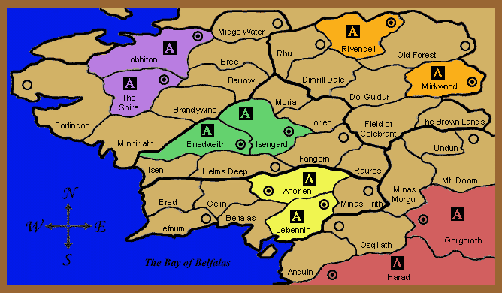
Figure 2. Sample of final map used

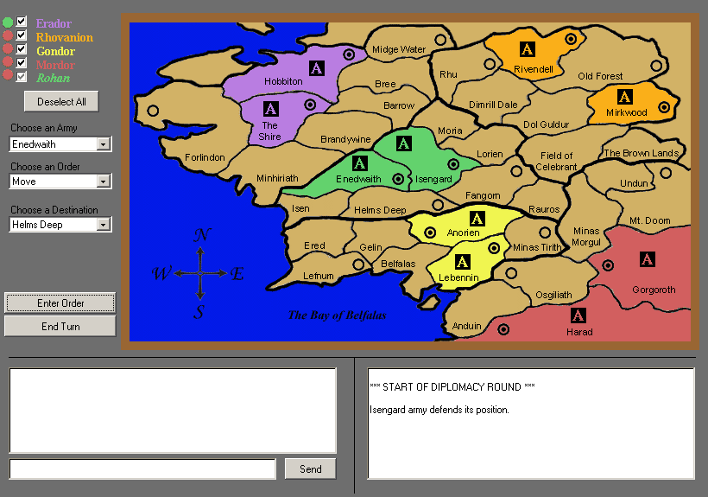
Figure 3. Moving an army
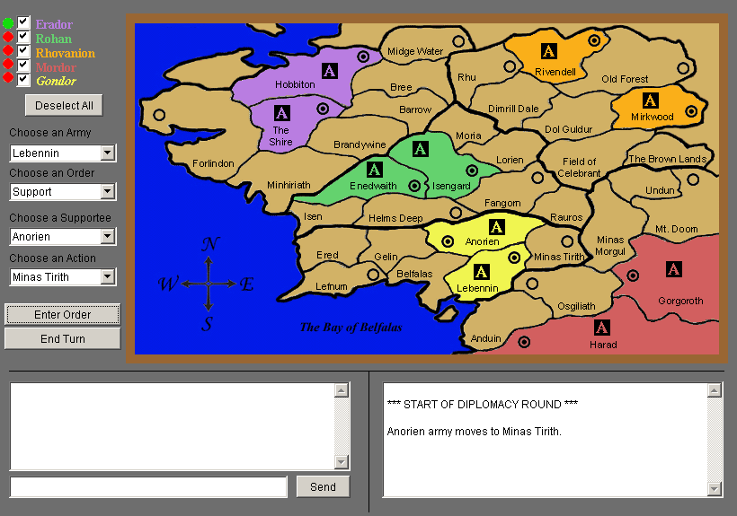
Figure 4. Supporting an army

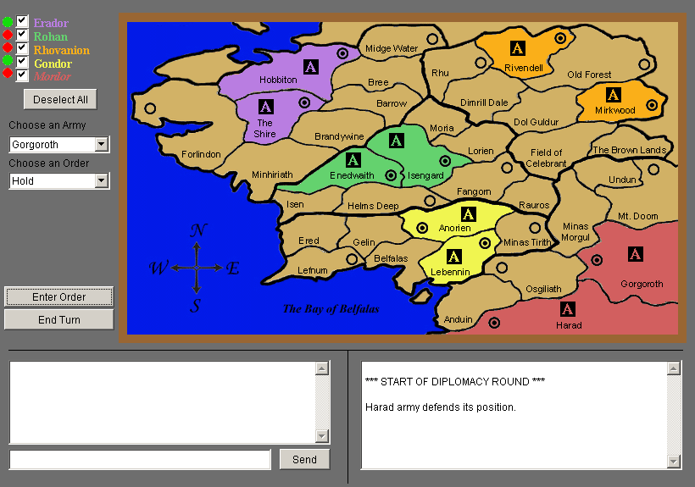
Figure 5. Holding an army

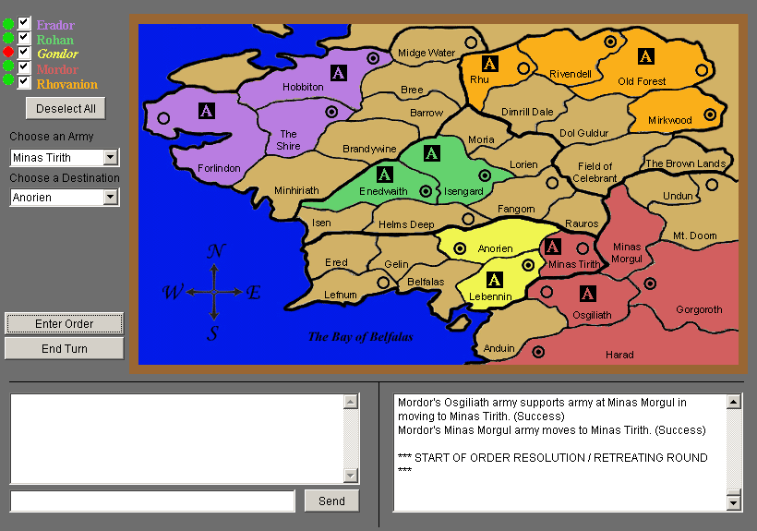
Figure 6. Retreating

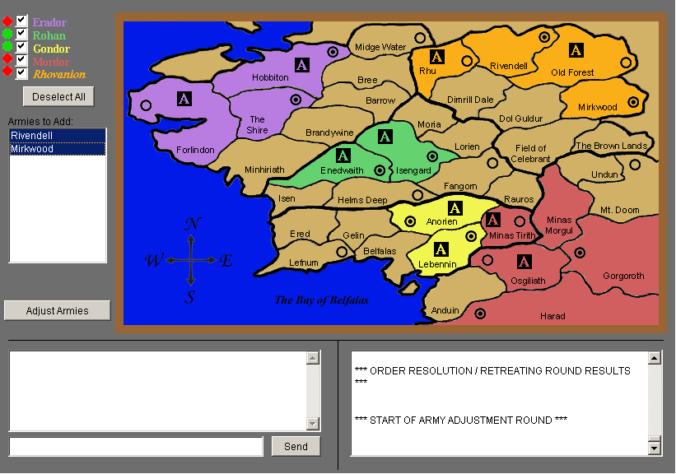Figure 7. Adding armies

Figure 7. Initial hand drawn version of map

GLOSSARY AND ACRONYM LIST

N/A – Not Applicable
SRD – System Requirements Document
UM – User Manual
DDD1 – Detailed Design Document 1
DDD2 – Detailed Design Document 2
CCS – Code and Coding Standard
STP – System Test Procedure
STR – System Test Report

